WEEK3 Spring Data JPA with Spring Boot, Hibernate

1.Spring Data JPA - Quick Example

pom.xml
<?xml version="1.0" encoding="UTF-8"?>
<project xmlns="http://maven.apache.org/POM/4.0.0" xmlns:xsi="http://www.w3.org/2001/XMLSchema-instance"
xsi:schemaLocation="http://maven.apache.org/POM/4.0.0 https://maven.apache.org/xsd/maven-4.0.0.xsd">
<modelVersion>4.0.0</modelVersion>
<parent>
<groupId>org.springframework.boot</groupId>
<artifactId>spring-boot-starter-parent</artifactId>
<version>3.5.3</version>
<relativePath/> <!-- lookup parent from repository -->
</parent>
<groupId>com.cognizant</groupId>
<artifactId>orm-learn</artifactId>
<version>0.0.1-SNAPSHOT</version>
<name>demo</name>
<description>Demo project for Spring Data JPA and Hibernate</description>
<url/>
<licenses>
<license/>
</licenses>
<developers>
<developer/>
</developers>
<scm>
<connection/>
<developerConnection/>
<tag/>
<url/>
</scm>
<properties>
<java.version>24</java.version>
</properties>
<dependencies>
<dependency>
<groupId>org.springframework.boot</groupId>
<artifactId>spring-boot-starter-data-jpa</artifactId>
</dependency>
<dependency>
<groupId>org.springframework.boot</groupId>
<artifactId>spring-boot-devtools</artifactId>
<scope>runtime</scope>
<optional>true</optional>
</dependency>
<dependency>
<groupId>com.mysql</groupId>
<artifactId>mysql-connector-j</artifactId>
<scope>runtime</scope>
</dependency>
<dependency>
<groupId>org.springframework.boot</groupId>
<artifactId>spring-boot-starter-test</artifactId>
<scope>test</scope>
</dependency>
</dependencies>

<build>
<plugins>
<plugin>
<groupId>org.springframework.boot</groupId>
<artifactId>spring-boot-maven-plugin</artifactId>
</plugin>
</plugins>
</build>

</project>
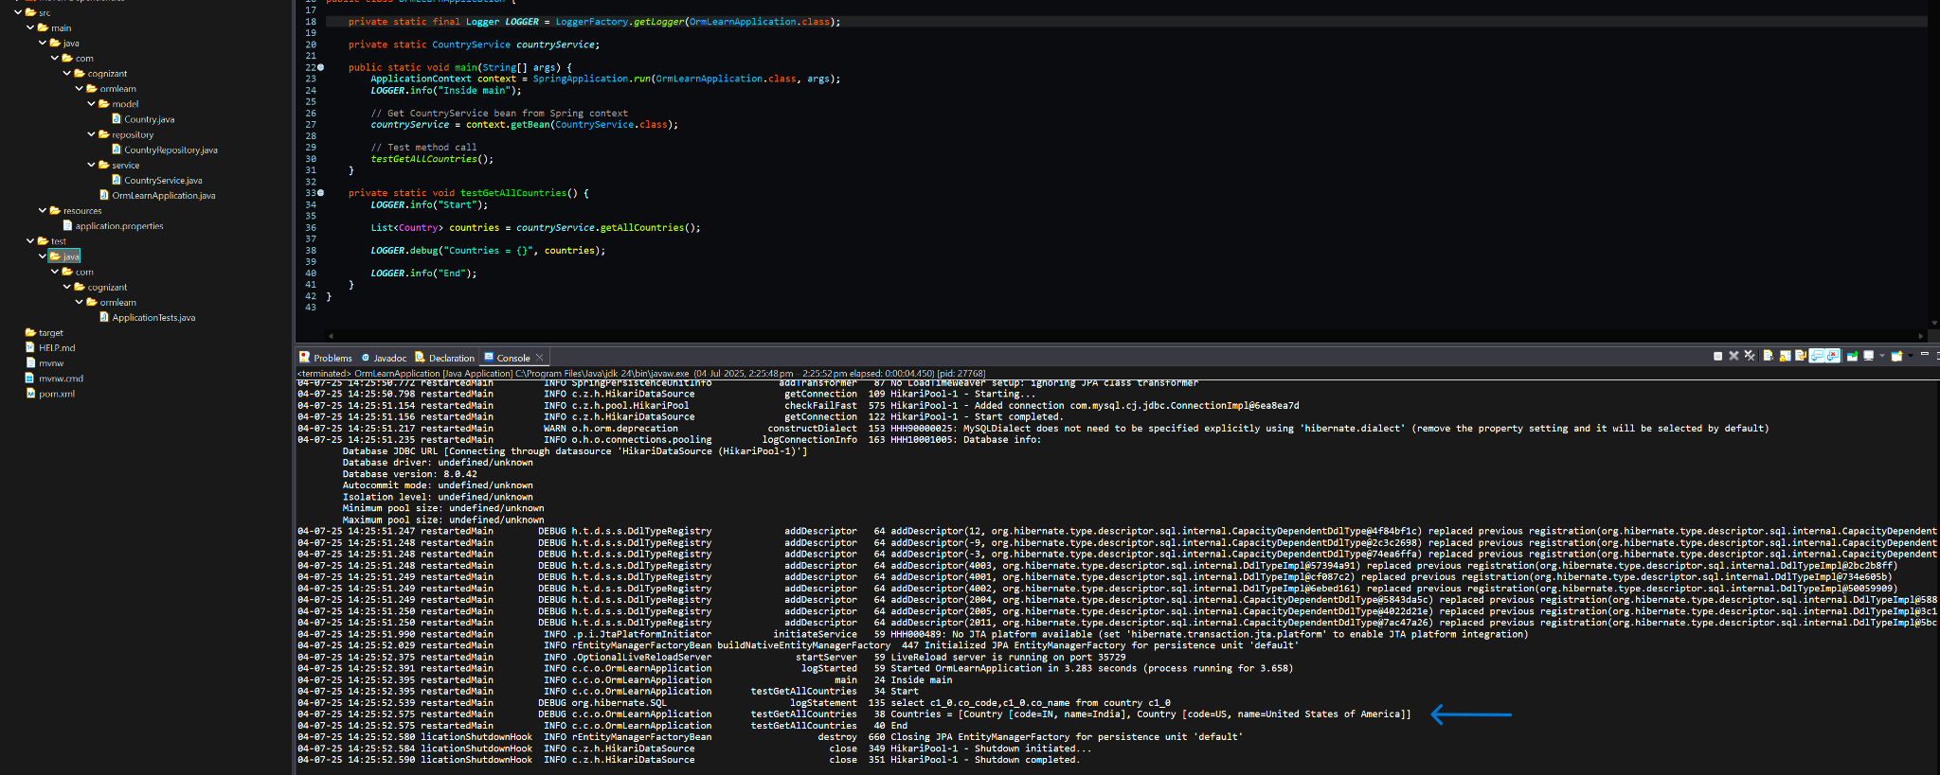
Output

2.Implement services for managing Country
pom.xml
<?xml version="1.0" encoding="UTF-8"?>
<project xmlns="http://maven.apache.org/POM/4.0.0" xmlns:xsi="http://www.w3.org/2001/XMLSchema-instance"
xsi:schemaLocation="http://maven.apache.org/POM/4.0.0 https://maven.apache.org/xsd/maven-4.0.0.xsd">
<modelVersion>4.0.0</modelVersion>
<parent>
<groupId>org.springframework.boot</groupId>
<artifactId>spring-boot-starter-parent</artifactId>
<version>3.5.3</version>
<relativePath/> <!-- lookup parent from repository -->
</parent>
<groupId>com.cognizant</groupId>
<artifactId>orm-learn</artifactId>
<version>0.0.1-SNAPSHOT</version>
<name>demo</name>
<description>Demo project for Spring Data JPA and Hibernate</description>
<url/>
<licenses>
<license/>
</licenses>
<developers>
<developer/>
</developers>
<scm>
<connection/>
<developerConnection/>
<tag/>
<url/>
</scm>
<properties>
<java.version>24</java.version>
</properties>
<dependencies>
<dependency>
<groupId>org.springframework.boot</groupId>
<artifactId>spring-boot-starter-data-jpa</artifactId>
</dependency>

<dependency>
<groupId>org.springframework.boot</groupId>
<artifactId>spring-boot-devtools</artifactId>
<scope>runtime</scope>
<optional>true</optional>
</dependency>
<dependency>
<groupId>com.mysql</groupId>
<artifactId>mysql-connector-j</artifactId>
<scope>runtime</scope>
</dependency>
<dependency>
<groupId>org.springframework.boot</groupId>
<artifactId>spring-boot-starter-test</artifactId>
<scope>test</scope>
</dependency>
</dependencies>

<build>
<plugins>
<plugin>
<groupId>org.springframework.boot</groupId>
<artifactId>spring-boot-maven-plugin</artifactId>
</plugin>
</plugins>
</build>

</project>
classpath
<?xml version="1.0" encoding="UTF-8"?>
<classpath>
<classpathentry kind="src" output="target/classes" path="src/main/java">
<attributes>
<attribute name="optional" value="true"/>
<attribute name="maven.pomderived" value="true"/>
</attributes>
</classpathentry>
<classpathentry excluding="**" kind="src" output="target/classes" path="src/main/resources">
<attributes>
<attribute name="maven.pomderived" value="true"/>
<attribute name="optional" value="true"/>
</attributes>
</classpathentry>
<classpathentry kind="src" output="target/test-classes" path="src/test/java">
<attributes>
<attribute name="optional" value="true"/>
<attribute name="maven.pomderived" value="true"/>
<attribute name="test" value="true"/>
</attributes>
</classpathentry>
<classpathentry excluding="**" kind="src" output="target/test-classes" path="src/test/resources">
<attributes>
<attribute name="maven.pomderived" value="true"/>
<attribute name="test" value="true"/>
<attribute name="optional" value="true"/>
</attributes>
</classpathentry>
<classpathentry kind="con" path="org.eclipse.jdt.launching.JRE_CONTAINER/org.eclipse.jdt.internal.debug.ui.launcher.StandardVMType/JavaSE-24">
<attributes>
<attribute name="maven.pomderived" value="true"/>
</attributes>
</classpathentry>
<classpathentry kind="con" path="org.eclipse.m2e.MAVEN2_CLASSPATH_CONTAINER">
<attributes>
<attribute name="maven.pomderived" value="true"/>
</attributes>
</classpathentry>
<classpathentry kind="output" path="target/classes"/>
</classpath>
Output:
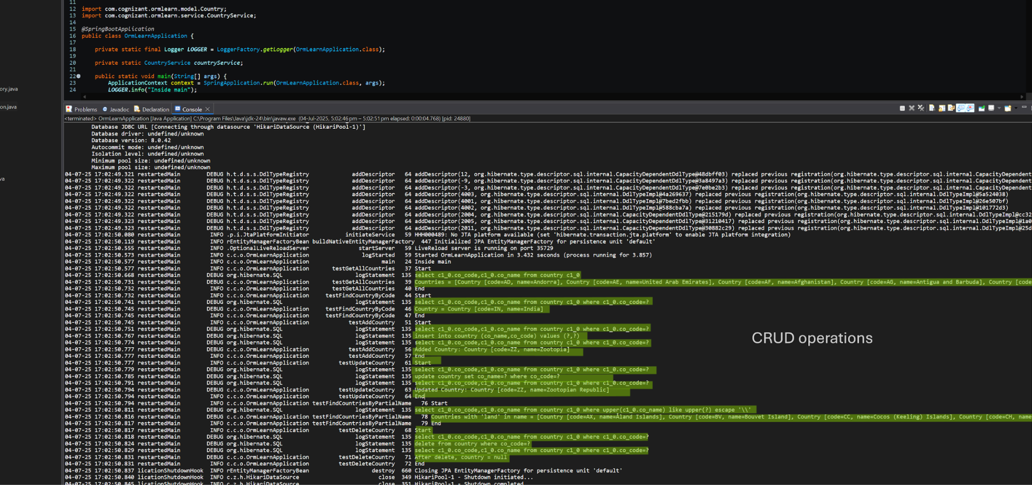

3.Add a new country
pom.xml
<?xml version="1.0" encoding="UTF-8"?>
<project xmlns="http://maven.apache.org/POM/4.0.0"
xmlns:xsi="http://www.w3.org/2001/XMLSchema-instance"
xsi:schemaLocation="http://maven.apache.org/POM/4.0.0 https://maven.apache.org/xsd/maven-4.0.0.xsd">

<modelVersion>4.0.0</modelVersion>

<parent>
<groupId>org.springframework.boot</groupId>
<artifactId>spring-boot-starter-parent</artifactId>
<version>3.5.3</version>
<relativePath/>
</parent>

<groupId>com.cognizant</groupId>
<artifactId>orm-learn</artifactId>
<version>0.0.1-SNAPSHOT</version>
<name>orm-learn</name>
<description>Spring Data JPA and Hibernate Demo</description>

<properties>
<java.version>24</java.version>
<mysql.version>8.3.0</mysql.version>
</properties>

<dependencies>
<!-- Spring Data JPA -->
<dependency>
<groupId>org.springframework.boot</groupId>
<artifactId>spring-boot-starter-data-jpa</artifactId>
</dependency>
<dependency>
<groupId>com.mysql</groupId>
<artifactId>mysql-connector-j</artifactId>
<version>${mysql.version}</version>
</dependency>
<dependency>
<groupId>org.springframework.boot</groupId>
<artifactId>spring-boot-devtools</artifactId>
<scope>runtime</scope>
<optional>true</optional>
</dependency>

<!-- Testing -->
<dependency>
<groupId>org.springframework.boot</groupId>
<artifactId>spring-boot-starter-test</artifactId>
<scope>test</scope>
</dependency>
</dependencies>

<build>
<plugins>
<!-- Spring Boot Maven Plugin -->
<plugin>
<groupId>org.springframework.boot</groupId>
<artifactId>spring-boot-maven-plugin</artifactId>
<version>3.5.3</version>
</plugin>
</plugins>
</build>

</project>

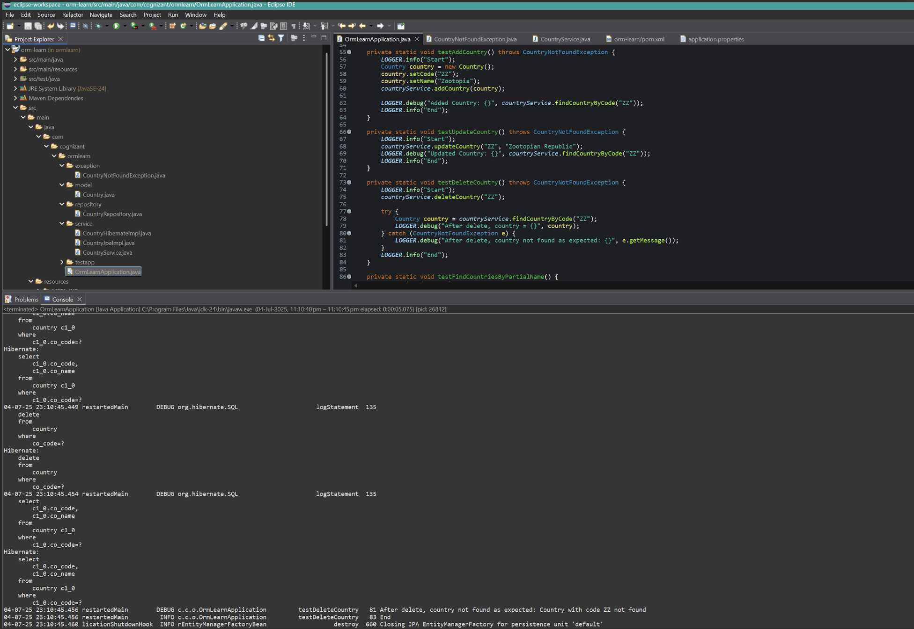
Output:

4.Difference between JPA, Hibernate and Spring Data JPA
<?xml version="1.0" encoding="UTF-8"?>
<project xmlns="http://maven.apache.org/POM/4.0.0"
xmlns:xsi="http://www.w3.org/2001/XMLSchema-instance"
xsi:schemaLocation="http://maven.apache.org/POM/4.0.0 https://maven.apache.org/xsd/maven-4.0.0.xsd">

<modelVersion>4.0.0</modelVersion>

<parent>
<groupId>org.springframework.boot</groupId>
<artifactId>spring-boot-starter-parent</artifactId>
<version>3.5.3</version>
<relativePath/>
</parent>

<groupId>com.cognizant</groupId>
<artifactId>orm-learn</artifactId>
<version>0.0.1-SNAPSHOT</version>
<name>orm-learn</name>
<description>Spring Data JPA and Hibernate Demo</description>

<properties>
<java.version>24</java.version>
<mysql.version>8.3.0</mysql.version>
</properties>

<dependencies>
<!-- Spring Data JPA -->
<dependency>
<groupId>org.springframework.boot</groupId>
<artifactId>spring-boot-starter-data-jpa</artifactId>
</dependency>

<!-- MySQL JDBC Driver -->
<dependency>
<groupId>com.mysql</groupId>
<artifactId>mysql-connector-j</artifactId>
<version>${mysql.version}</version>
</dependency>

<!-- Spring Boot Devtools -->
<dependency>
<groupId>org.springframework.boot</groupId>
<artifactId>spring-boot-devtools</artifactId>
<scope>runtime</scope>
<optional>true</optional>
</dependency>

<!-- Testing -->
<dependency>
<groupId>org.springframework.boot</groupId>
<artifactId>spring-boot-starter-test</artifactId>
<scope>test</scope>
</dependency>
</dependencies>
<build>
<plugins>
<!-- Spring Boot Maven Plugin -->
<plugin>
<groupId>org.springframework.boot</groupId>
<artifactId>spring-boot-maven-plugin</artifactId>
<version>3.5.3</version>
</plugin>
</plugins>
</build>
</project>

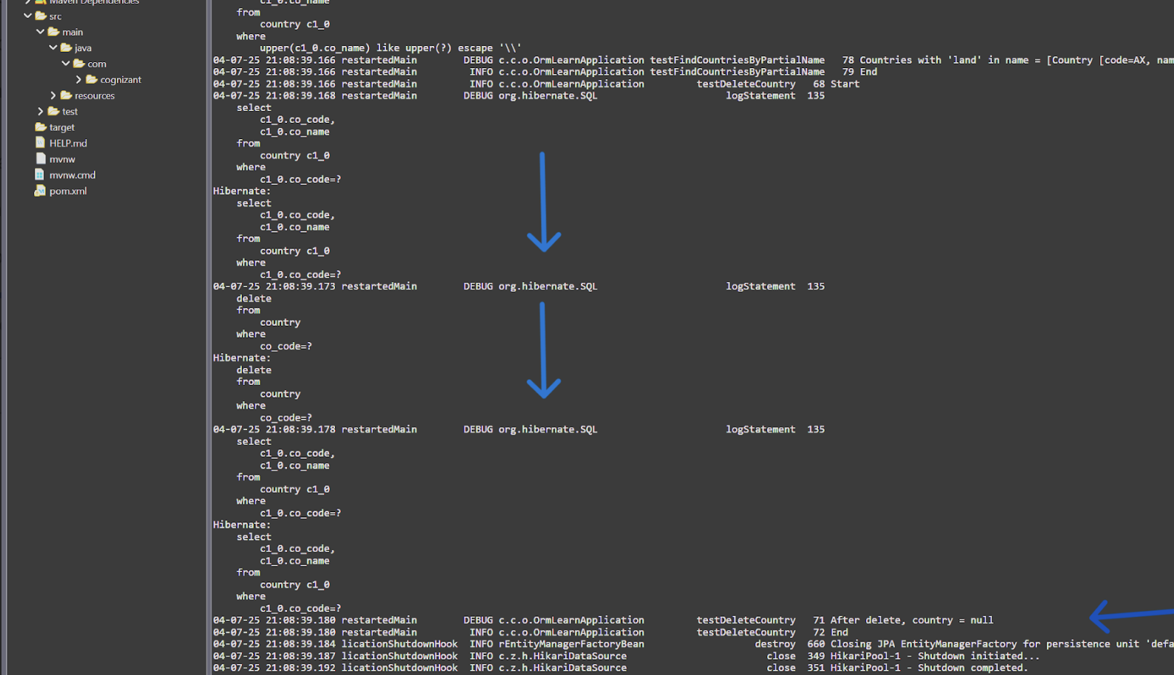
Output:

5.Demonstrate implementation of Query Methods feature of Spring Data JPA
<?xml version="1.0" encoding="UTF-8"?>
<project xmlns="http://maven.apache.org/POM/4.0.0"
xmlns:xsi="http://www.w3.org/2001/XMLSchema-instance"
xsi:schemaLocation="http://maven.apache.org/POM/4.0.0 https://maven.apache.org/xsd/maven-4.0.0.xsd">

<modelVersion>4.0.0</modelVersion>

<parent>
<groupId>org.springframework.boot</groupId>
<artifactId>spring-boot-starter-parent</artifactId>
<version>3.5.3</version>
<relativePath/>
</parent>

<groupId>com.cognizant</groupId>
<artifactId>orm-learn</artifactId>
<version>0.0.1-SNAPSHOT</version>
<name>orm-learn</name>
<description>Spring Data JPA and Hibernate Demo</description>

<properties>
<java.version>24</java.version>
<mysql.version>8.3.0</mysql.version>
</properties>

<dependencies>
<!-- Spring Data JPA -->
<dependency>
<groupId>org.springframework.boot</groupId>
<artifactId>spring-boot-starter-data-jpa</artifactId>
</dependency>

<!-- MySQL JDBC Driver -->
<dependency>
<groupId>com.mysql</groupId>
<artifactId>mysql-connector-j</artifactId>
<version>${mysql.version}</version>
</dependency>

<!-- Spring Boot Devtools -->
<dependency>
<groupId>org.springframework.boot</groupId>
<artifactId>spring-boot-devtools</artifactId>
<scope>runtime</scope>
<optional>true</optional>
</dependency>

<!-- Testing -->
<dependency>
<groupId>org.springframework.boot</groupId>
<artifactId>spring-boot-starter-test</artifactId>
<scope>test</scope>
</dependency>
</dependencies>
<build>
<plugins>
<!-- Spring Boot Maven Plugin -->
<plugin>
<groupId>org.springframework.boot</groupId>
<artifactId>spring-boot-maven-plugin</artifactId>
<version>3.5.3</version>
</plugin>
</plugins>
</build>
</project>

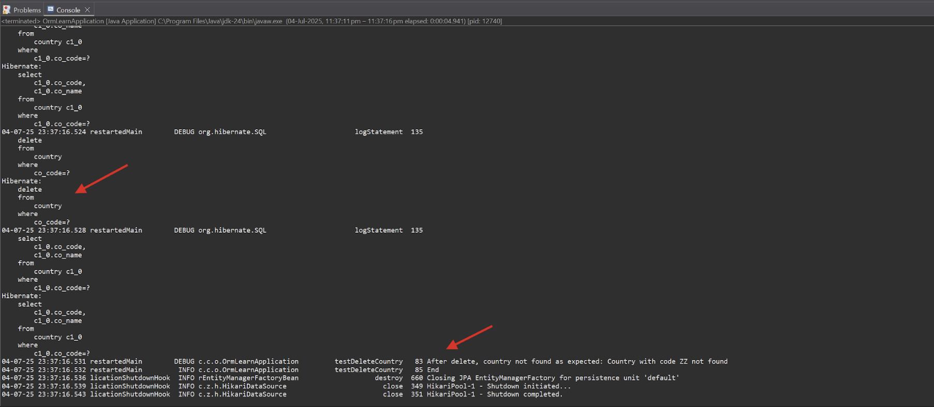
Output:

